**API Test Case Execution of Restful Booker**

1. TC1 - Auth Request with valid Credentials

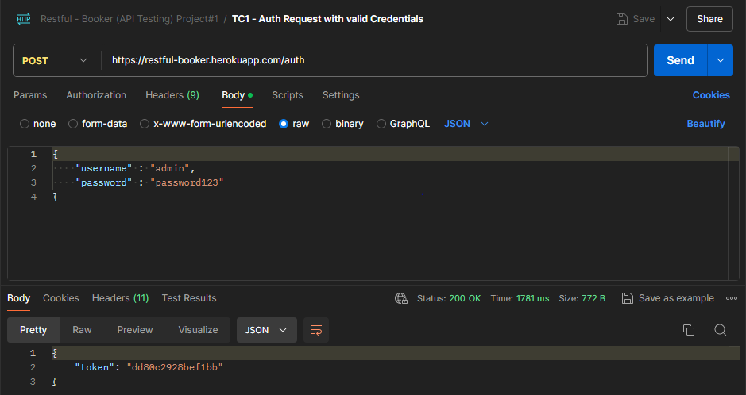

**Url** 🡪 <https://restful-booker.herokuapp.com/auth>

**Url** **Method** 🡪 POST

**Data** 🡪 Valid User name 🡪 admin

Valid Password 🡪 password123

**Response** 🡪 Token Generated (Pass)

**Status** 🡪 200 OK

1. TC2 - Auth Request with Invalid Credentials

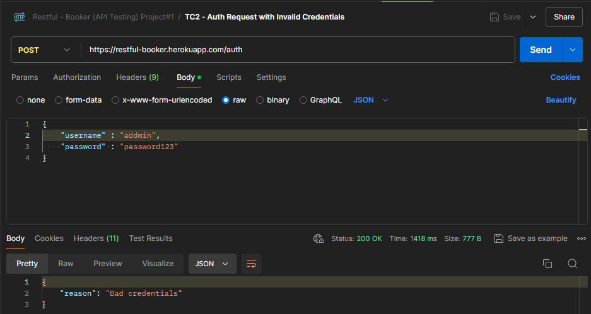

**Url** 🡪 <https://restful-booker.herokuapp.com/auth>

**Url** **Method** 🡪 POST

**Data** 🡪 Invalid User name 🡪 addmin

Valid Password 🡪 password123

**Response** 🡪 Bad Credentials (Pass)

**Status** 🡪 200 OK

1. TC3 - Auth Request with Invalid Credentials

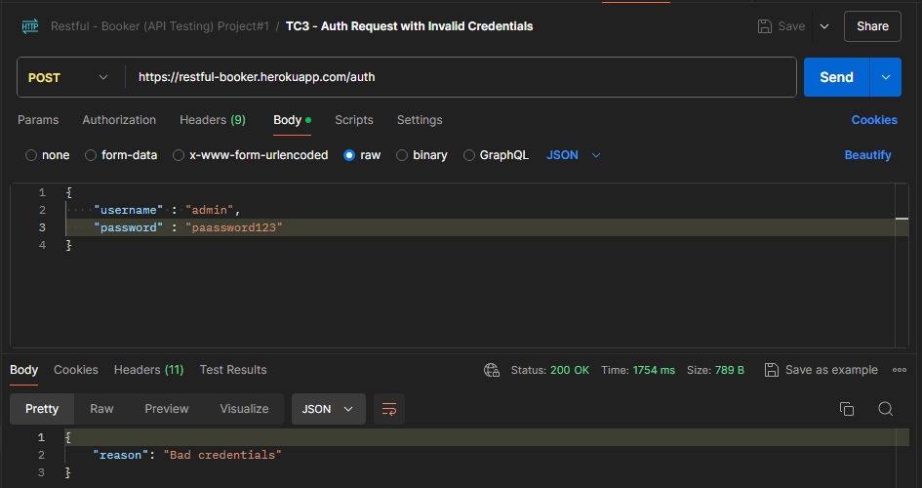

**Url** 🡪 <https://restful-booker.herokuapp.com/auth>

**Url** **Method** 🡪 POST

**Data** 🡪 Valid User name 🡪 admin

Invalid Password 🡪 paassword123

**Response** 🡪 Bad Credentials (Pass)

**Status** 🡪 200 OK

1. TC4 - Auth Request with Empty Credential

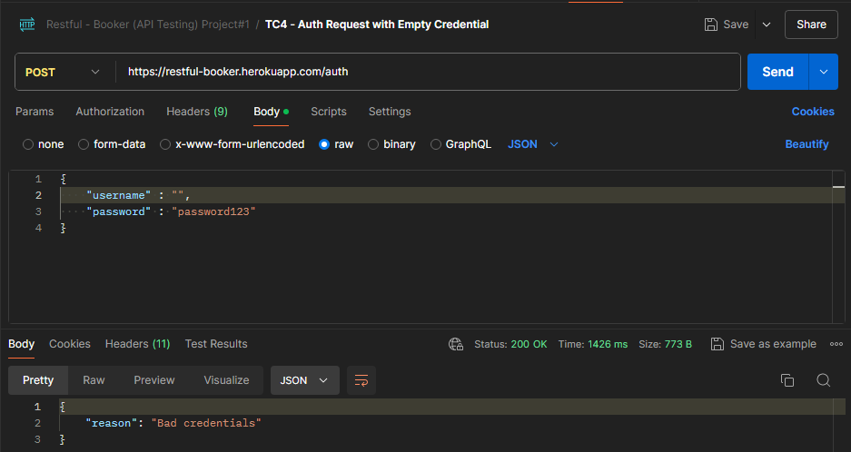

**Url** 🡪 <https://restful-booker.herokuapp.com/auth>

**Url** **Method** 🡪 POST

**Data** 🡪 Empty User name 🡪

Valid Password 🡪 password123

**Response** 🡪 Bad Credentials (Pass)

**Status** 🡪 200 OK

1. TC5 - Auth Request with Empty Credential

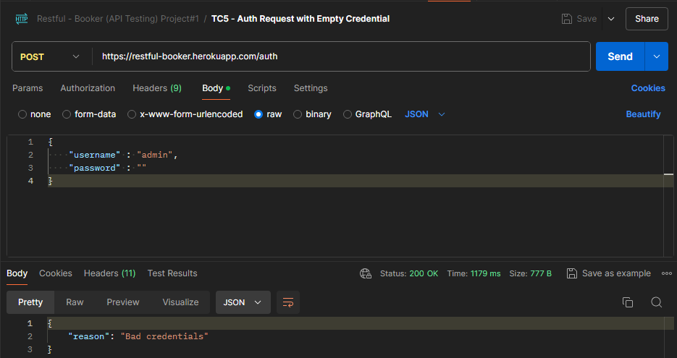

**Url** 🡪 <https://restful-booker.herokuapp.com/auth>

**Url** **Method** 🡪 POST

**Data** 🡪 Valid User name 🡪 admin

Empty Password 🡪

**Response** 🡪 Bad Credentials (Pass)

**Status** 🡪 200 OK

1. TC6 – Create New Booking

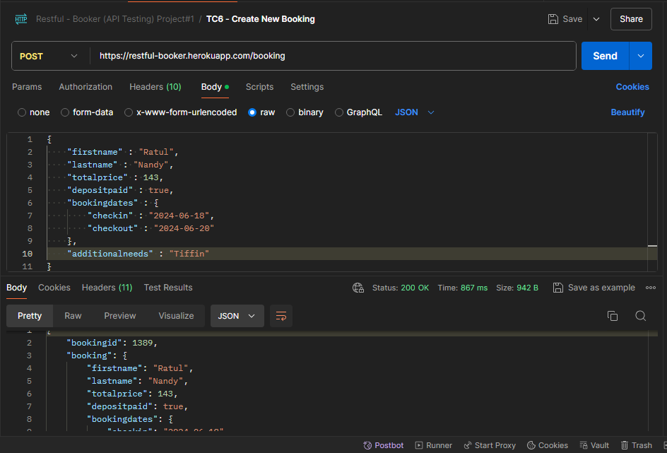

**Url** 🡪 <https://restful-booker.herokuapp.com/booking>

**Url Method** 🡪 POST

**JSON raw Data** 🡪

{

    "firstname" : "Ratul",

    "lastname" : "Nandy",

    "totalprice" : 143,

    "depositpaid" : true,

    "bookingdates" : {

        "checkin" : "2024-06-18",

        "checkout" : "2024-06-20"

    },

    "additionalneeds" : "Tiffin"

}

**Response** 🡪 Booking ID Generated with details (Pass)

{

    "bookingid": 1389,

    "booking": {

        "firstname": "Ratul",

        "lastname": "Nandy",

        "totalprice": 143,

        "depositpaid": true,

        "bookingdates": {

            "checkin": "2024-06-18",

            "checkout": "2024-06-20"

        },

        "additionalneeds": "Tiffin"

    }

}

**Status** 🡪 200 OK

1. TC7 – Create New Booking with Duplicate Data

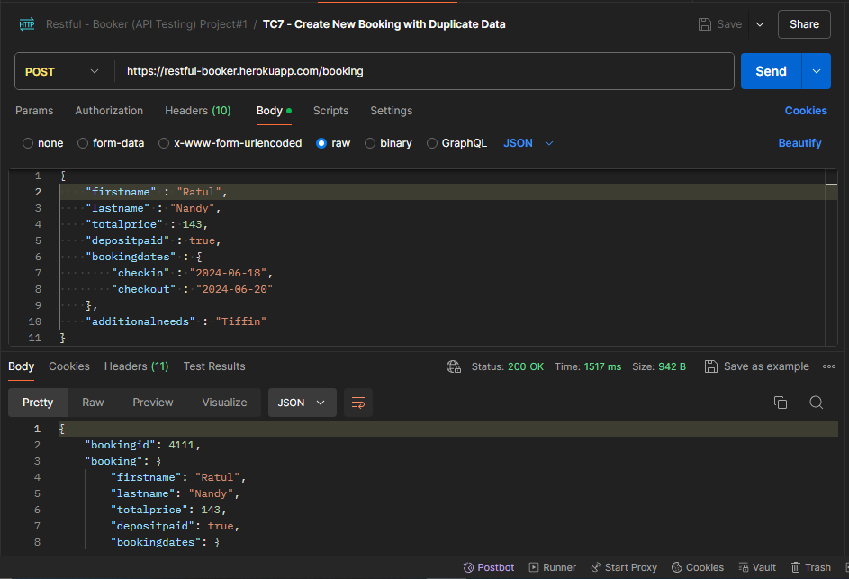

**Url** 🡪 <https://restful-booker.herokuapp.com/booking>

**Url Method** 🡪 POST

**JSON raw Data** 🡪

{

    "firstname" : "Ratul",

    "lastname" : "Nandy",

    "totalprice" : 143,

    "depositpaid" : true,

    "bookingdates" : {

        "checkin" : "2024-06-18",

        "checkout" : "2024-06-20"

    },

    "additionalneeds" : "Tiffin"

}

**Response** 🡪 New Booking ID Generated with Duplicate Details (**Fail**)

{

    "bookingid": 4111,

    "booking": {

        "firstname": "Ratul",

        "lastname": "Nandy",

        "totalprice": 143,

        "depositpaid": true,

        "bookingdates": {

            "checkin": "2024-06-18",

            "checkout": "2024-06-20"

        },

        "additionalneeds": "Tiffin"

    }

}

**Status** 🡪 200 OK

1. TC8 – Create New Booking with Partial Empty Data

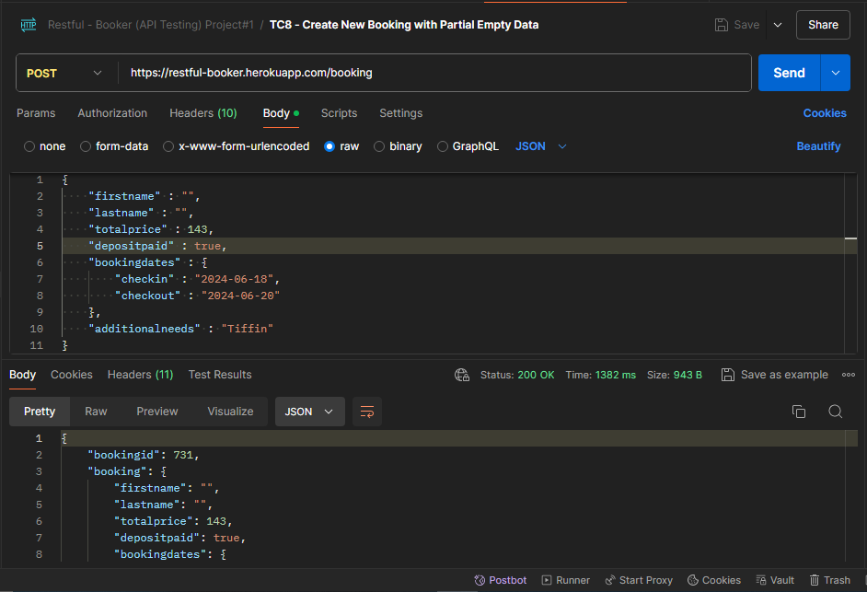

**Url** 🡪 <https://restful-booker.herokuapp.com/booking>

**Url Method** 🡪 POST

**JSON raw Data** 🡪

{

    "firstname" : "",

    "lastname" : "",

    "totalprice" : 143,

    "depositpaid" : true,

    "bookingdates" : {

        "checkin" : "2024-06-18",

        "checkout" : "2024-06-20"

    },

    "additionalneeds" : "Tiffin"

}

**Response** 🡪 New Booking ID Generated with Empty Data (**Fail**)

{

    "bookingid": 731,

    "booking": {

        "firstname": "",

        "lastname": "",

        "totalprice": 143,

        "depositpaid": true,

        "bookingdates": {

            "checkin": "2024-06-18",

            "checkout": "2024-06-20"

        },

        "additionalneeds": "Tiffin"

    }

}

**Status** 🡪 200 OK

1. TC9 – Create New Booking with Entire Empty Data

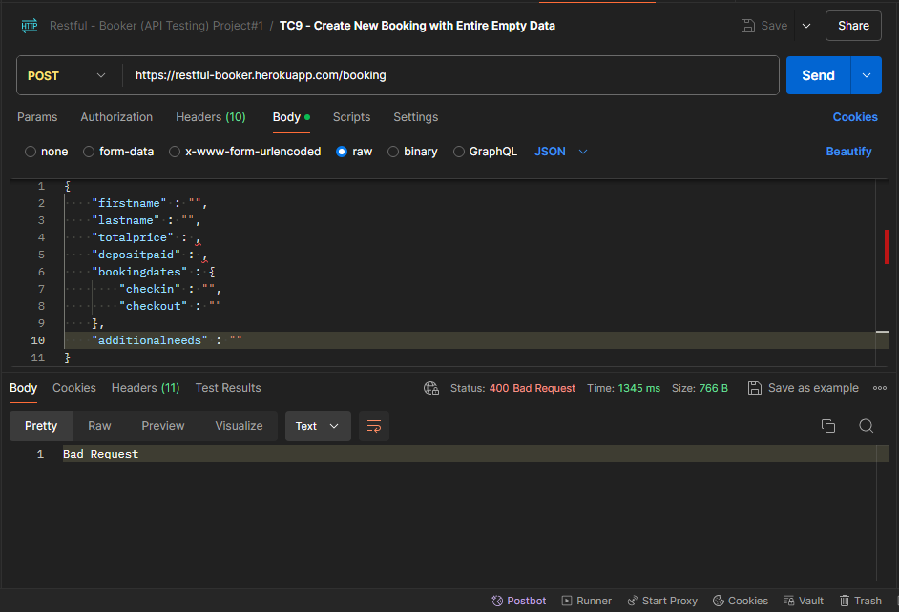

**Url** 🡪 <https://restful-booker.herokuapp.com/booking>

**Url Method** 🡪 POST

**JSON raw Data** 🡪

{

    "firstname" : "",

    "lastname" : "",

    "totalprice" :,

    "depositpaid" :,

    "bookingdates" : {

        "checkin" : "",

        "checkout" : ""

    },

    "additionalneeds" : ""

}

**Response** 🡪 Bad Request (**Pass**)

**Status** 🡪 400 Bad Request

1. TC10 – Create New Booking with Invalid First Name

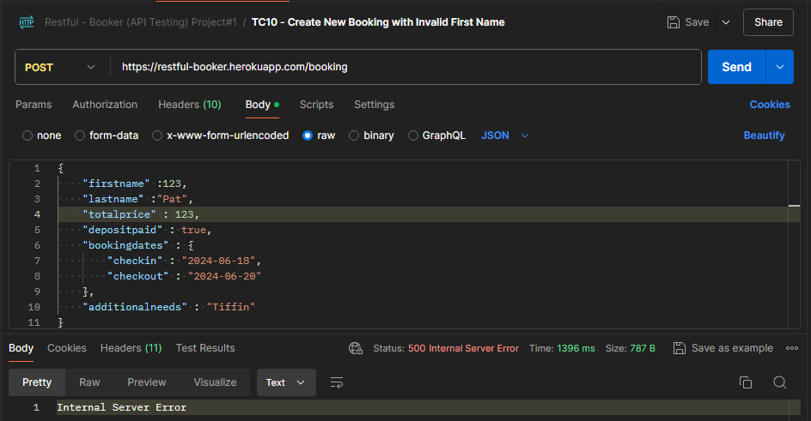

**Url** 🡪 <https://restful-booker.herokuapp.com/booking>

**Url Method** 🡪 POST

**JSON raw Data** 🡪

{

    "firstname" : **123**,

    "lastname" : "Pat",

    "totalprice" : 123,

    "depositpaid" : true,

    "bookingdates" : {

        "checkin" : "2024-06-18",

        "checkout" : "2024-06-20"

    },

    "additionalneeds" : "Tiffin"

}

**Response** 🡪 Internal Server Error (**Pass**)

**Status** 🡪 500 Internal Server Error

1. TC11 – Create New Booking with Invalid Last Name

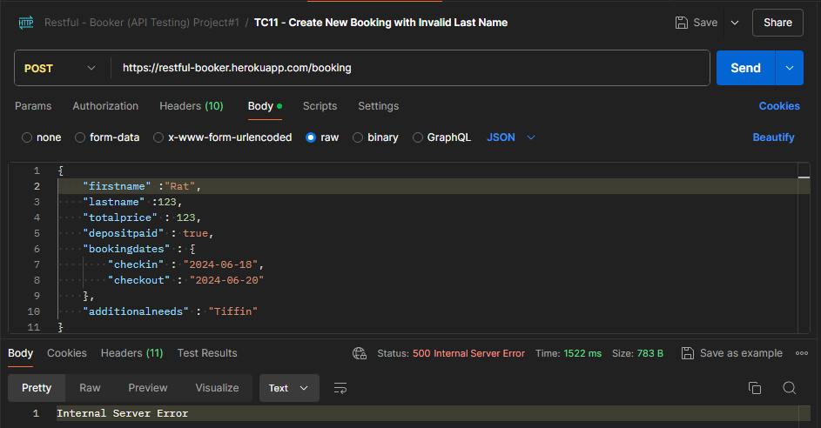

**Url** 🡪 <https://restful-booker.herokuapp.com/booking>

**Url Method** 🡪 POST

**JSON raw Data** 🡪

{

    "firstname" : “Rat”,

    "lastname" : **123**,

    "totalprice" : 123,

    "depositpaid" : true,

    "bookingdates" : {

        "checkin" : "2024-06-18",

        "checkout" : "2024-06-20"

    },

    "additionalneeds" : "Tiffin"

}

**Response** 🡪 Internal Server Error (**Pass**)

**Status** 🡪 500 Internal Server Error

1. TC12 – Create New Booking with Invalid Total Price

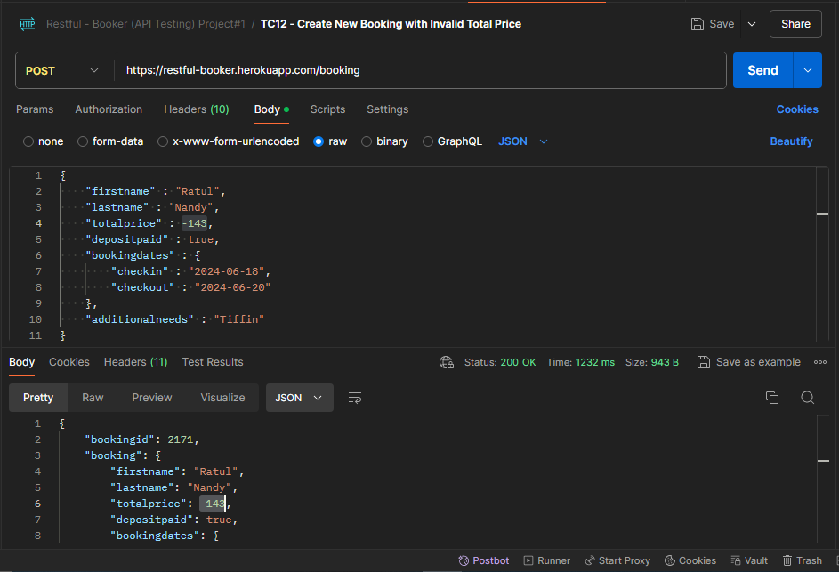

**Url** 🡪 <https://restful-booker.herokuapp.com/booking>

**Url Method** 🡪 POST

**JSON raw Data** 🡪

{

    "firstname" : "Ratul",

    "lastname" : "Nandy",

    "totalprice" : -143,

    "depositpaid" : true,

    "bookingdates" : {

        "checkin" : "2024-06-18",

        "checkout" : "2024-06-20"

    },

    "additionalneeds" : "Tiffin"

}

**Response** 🡪 Booking ID created with Invalid Total Price (**Fail**)

{

    "bookingid": 2171,

    "booking": {

        "firstname": "Ratul",

        "lastname": "Nandy",

        "totalprice": -143,

        "depositpaid": true,

        "bookingdates": {

            "checkin": "2024-06-18",

            "checkout": "2024-06-20"

        },

        "additionalneeds": "Tiffin"

    }

}

**Status** 🡪 200 OK

1. TC13 – Create New Booking with Invalid Total Price

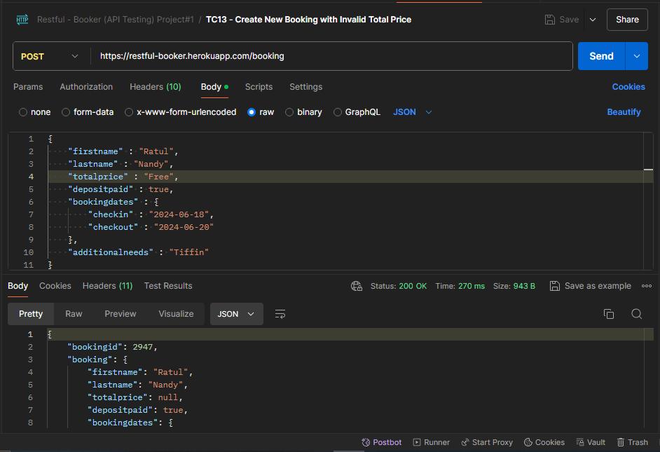

**Url** 🡪 <https://restful-booker.herokuapp.com/booking>

**Url Method** 🡪 POST

**JSON raw Data** 🡪

{

    "firstname" : "Ratul",

    "lastname" : "Nandy",

    "totalprice" : "Free",

    "depositpaid" : true,

    "bookingdates" : {

        "checkin" : "2024-06-18",

        "checkout" : "2024-06-20"

    },

    "additionalneeds" : "Tiffin"

}

**Response** 🡪 Booking ID created with Invalid Total Price (**Fail**)

{

    "bookingid": 2947,

    "booking": {

        "firstname": "Ratul",

        "lastname": "Nandy",

        "totalprice": null,

        "depositpaid": true,

        "bookingdates": {

            "checkin": "2024-06-18",

            "checkout": "2024-06-20"

        },

        "additionalneeds": "Tiffin"

    }

}

**Status** 🡪 200 OK

1. TC14 – Create New Booking with Invalid Total Price

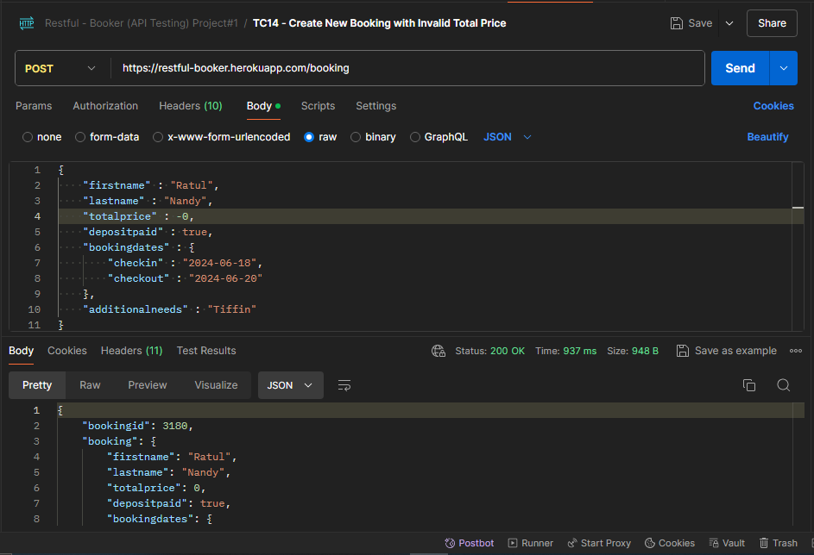

**Url** 🡪 <https://restful-booker.herokuapp.com/booking>

**Url Method** 🡪 POST

**JSON raw Data** 🡪

{

    "firstname" : "Ratul",

    "lastname" : "Nandy",

    "totalprice" : -0,

    "depositpaid" : true,

    "bookingdates" : {

        "checkin" : "2024-06-18",

        "checkout" : "2024-06-20"

    },

    "additionalneeds" : "Tiffin"

}

**Response** 🡪 Booking ID created with Invalid Total Price (**Fail**)

{

    "bookingid": 3180,

    "booking": {

        "firstname": "Ratul",

        "lastname": "Nandy",

        "totalprice": 0,

        "depositpaid": true,

        "bookingdates": {

            "checkin": "2024-06-18",

            "checkout": "2024-06-20"

        },

        "additionalneeds": "Tiffin"

    }

}

**Status** 🡪 200 OK

1. TC15 – Create New Booking with Empty Date

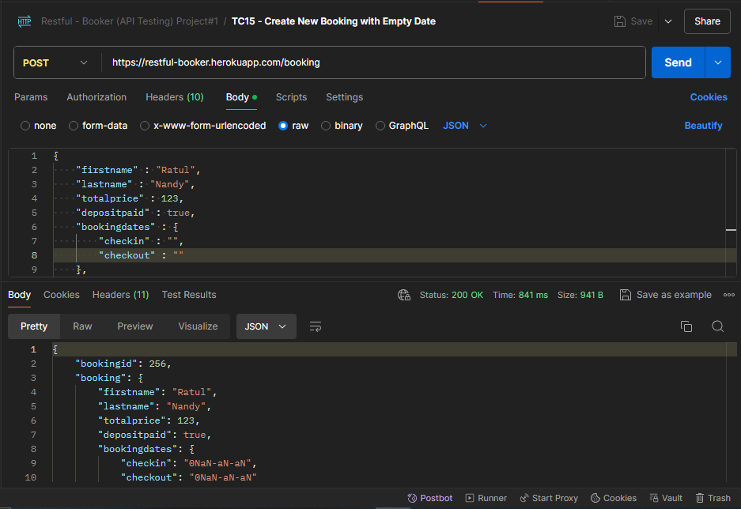

**Url** 🡪 <https://restful-booker.herokuapp.com/booking>

**Url Method** 🡪 POST

**JSON raw Data** 🡪

{

    "firstname" : "Ratul",

    "lastname" : "Nandy",

    "totalprice" : 123,

    "depositpaid" : true,

    "bookingdates" : {

        "checkin" : "",

        "checkout" : ""

    },

    "additionalneeds" : "Tiffin"

}

**Response** 🡪 Booking ID created with Empty Date (**Fail**)

{

    "bookingid": 256,

    "booking": {

        "firstname": "Ratul",

        "lastname": "Nandy",

        "totalprice": 123,

        "depositpaid": true,

        "bookingdates": {

            "checkin": "0NaN-aN-aN",

            "checkout": "0NaN-aN-aN"

        },

        "additionalneeds": "Tiffin"

    }

}

**Status** 🡪 200 OK

1. TC16 – Get All Bookings

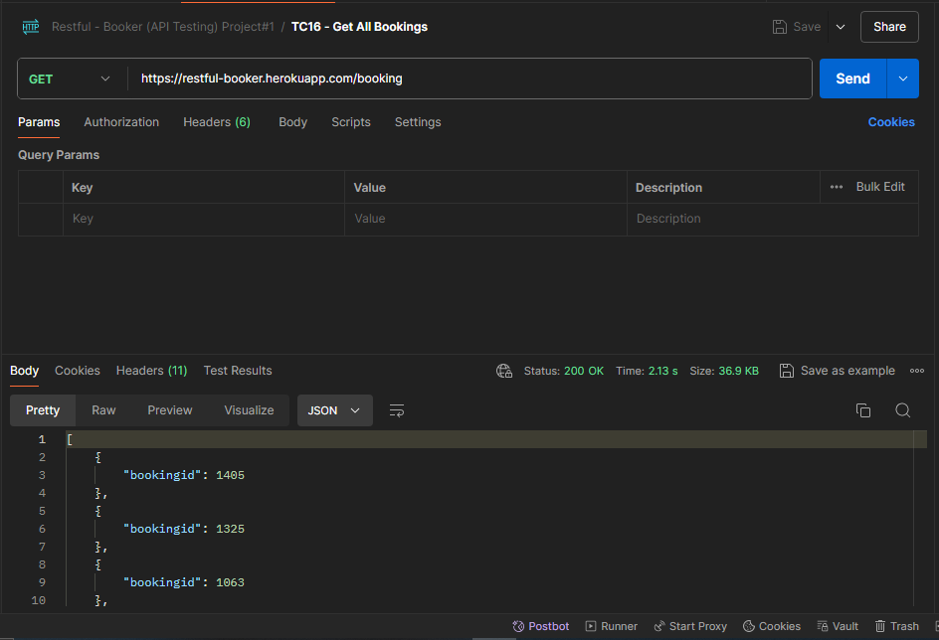

**Url** 🡪 <https://restful-booker.herokuapp.com/booking>

**Url Method** 🡪 GET

**JSON raw Data** 🡪

**Response** 🡪 All Booking ID Generated Successfully (**Pass**)

[

{

    "bookingid": 1405

},

   {

"bookingid": 1325

},

{

    "bookingid": 1063

},

.

.

.

   {

"bookingid": 2588

},

]

**Status** 🡪 200 OK

1. TC17 – Get All Bookings - by firstname

2 Steps needed to perform, to verify: -

1. Create a fresh booking
2. Search by first name

Creating a fresh booking

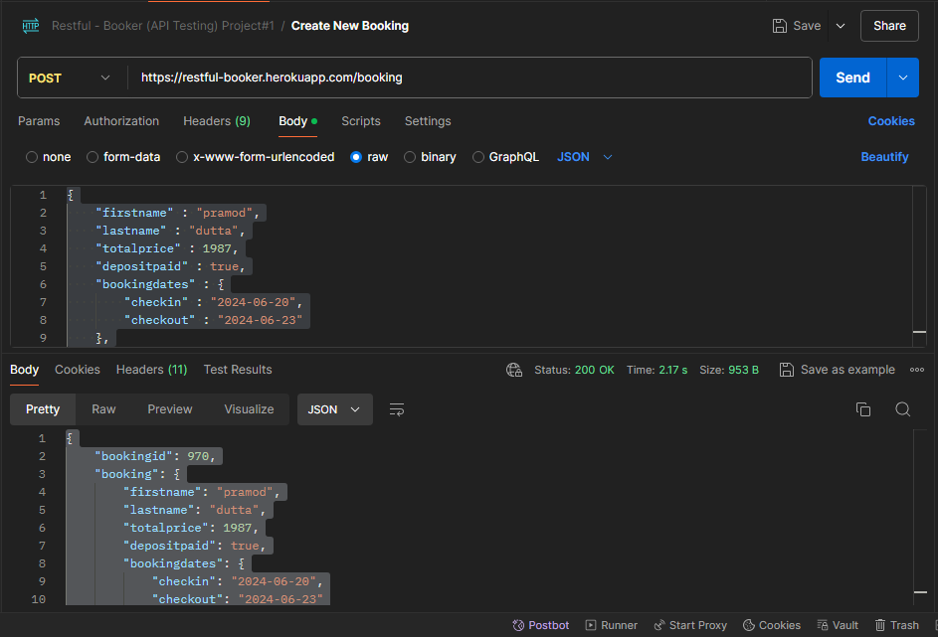

**Url** 🡪 <https://restful-booker.herokuapp.com/booking>

**Url Method** 🡪 POST

**JSON raw Data** 🡪

{

    "firstname" : "pramod",

    "lastname" : "dutta",

    "totalprice" : 1987,

    "depositpaid" : true,

    "bookingdates" : {

        "checkin" : "2024-06-20",

        "checkout" : "2024-06-23"

    },

    "additionalneeds" : "Balapele"

}

**Response** 🡪 Booking ID Generated Successfully (**Pass**)

{

    "bookingid": 970,

    "booking": {

        "firstname": "pramod",

        "lastname": "dutta",

        "totalprice": 1987,

        "depositpaid": true,

        "bookingdates": {

            "checkin": "2024-06-20",

            "checkout": "2024-06-23"

        },

        "additionalneeds": "Balapele"

    }

}

**Status** 🡪 200 OK

Searching by first name

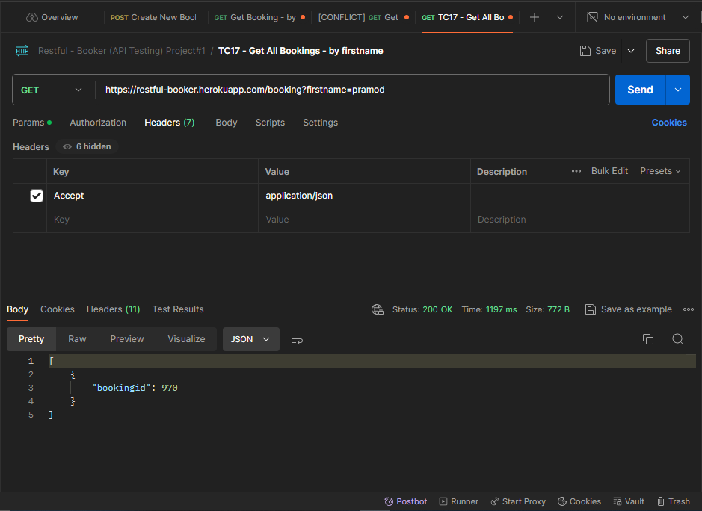

**Url** 🡪 <https://restful-booker.herokuapp.com/booking?firstname=pramod>

**Url Method** 🡪 GET

**Headers** 🡪

Accept:application/json

**Parameters 🡪**

firstname:pramod

**Response** 🡪 Booking ID Retrieved Successfully (**Pass**)

[

{

"bookingid": 970

}

]

**Status** 🡪 200 OK

1. TC18 – Get All Bookings - by firstname & lastname
2. Steps needed to perform, to verify: -
3. Create a fresh booking
4. Search by first name

Creating a fresh booking

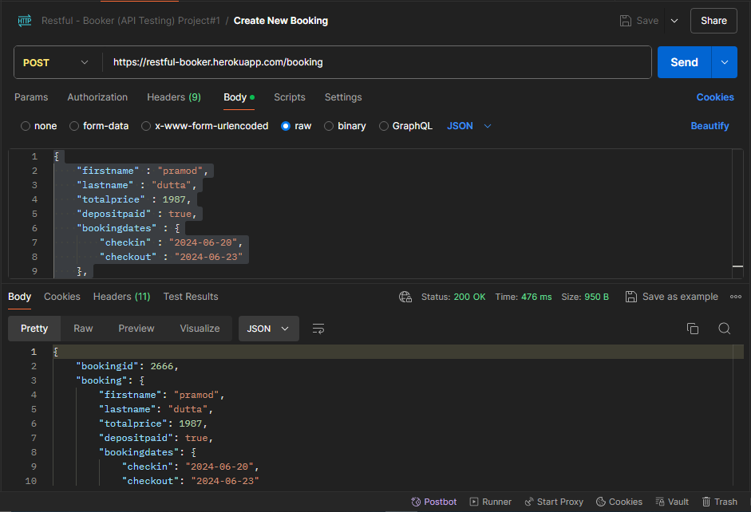

**Url** 🡪 <https://restful-booker.herokuapp.com/booking>

**Url Method** 🡪 POST

**JSON raw Data** 🡪

{

    "firstname" : "pramod",

    "lastname" : "dutta",

    "totalprice" : 1987,

    "depositpaid" : true,

    "bookingdates" : {

        "checkin" : "2024-06-20",

        "checkout" : "2024-06-23"

    },

    "additionalneeds" : "Balapele"

}

**Response** 🡪 Booking ID Generated Successfully (**Pass**)

{

    "bookingid": 2666,

    "booking": {

        "firstname": "pramod",

        "lastname": "dutta",

        "totalprice": 1987,

        "depositpaid": true,

        "bookingdates": {

            "checkin": "2024-06-20",

            "checkout": "2024-06-23"

        },

        "additionalneeds": "Balapele"

    }

}

**Status** 🡪 200 OK

Searching by first name & last name

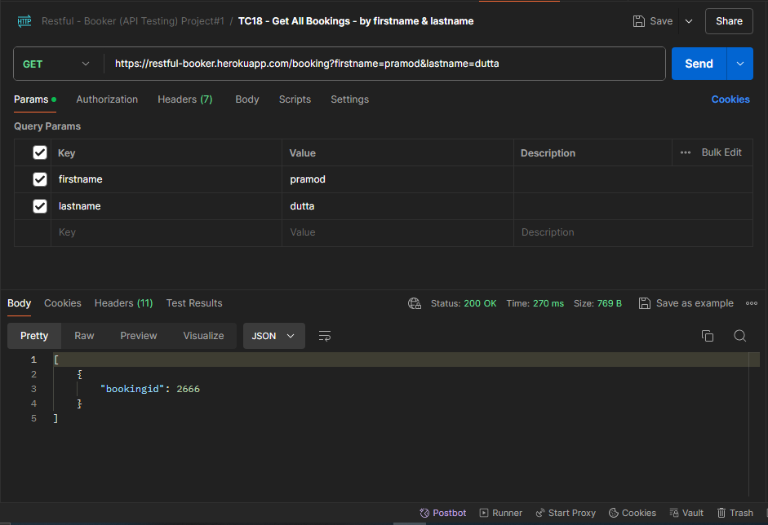

**Url** 🡪 <https://restful-booker.herokuapp.com/booking?firstname=pramod&lastname=dutta>

**Url Method** 🡪 GET

**Headers** 🡪

Accept:application/json

**Parameters 🡪**

firstname:pramod

lastname:dutta

**Response** 🡪 Booking ID Retrieved Successfully (**Pass**)

[

{

"bookingid": 2666

}

]

**Status** 🡪 200 OK

1. TC19 – Get Booking - by ID
2. Steps needed to perform, to verify: -
3. Create a fresh booking
4. Search by ID

Creating a fresh booking

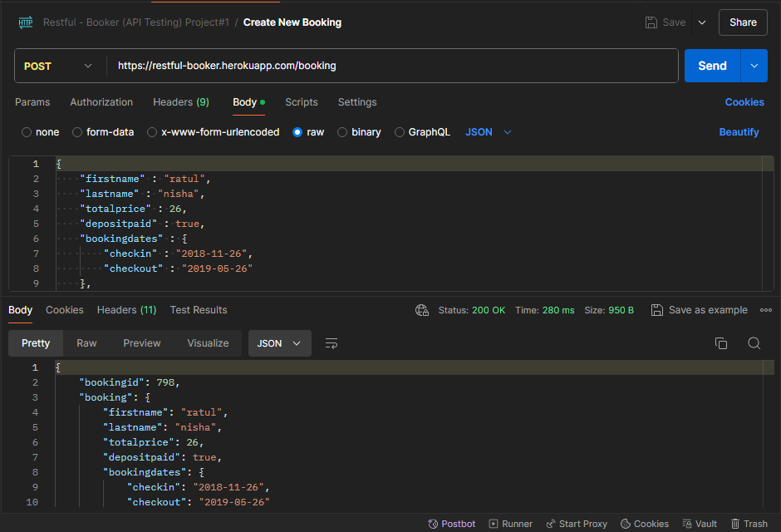

**Url** 🡪 <https://restful-booker.herokuapp.com/booking>

**Url Method** 🡪 POST

**JSON raw Data** 🡪

{

    "firstname" : "ratul",

    "lastname" : "nisha",

    "totalprice" : 26,

    "depositpaid" : true,

    "bookingdates" : {

        "checkin" : "2018-11-26",

        "checkout" : "2019-05-26"

    },

    "additionalneeds" : "Birthday"

}

**Response** 🡪 Booking ID Generated Successfully (**Pass**)

{

    "bookingid": 798,

    "booking": {

        "firstname": "ratul",

        "lastname": "nisha",

        "totalprice": 26,

        "depositpaid": true,

        "bookingdates": {

            "checkin": "2018-11-26",

            "checkout": "2019-05-26"

        },

        "additionalneeds": "Birthday"

    }

}

**Status** 🡪 200 OK

Searching by ID

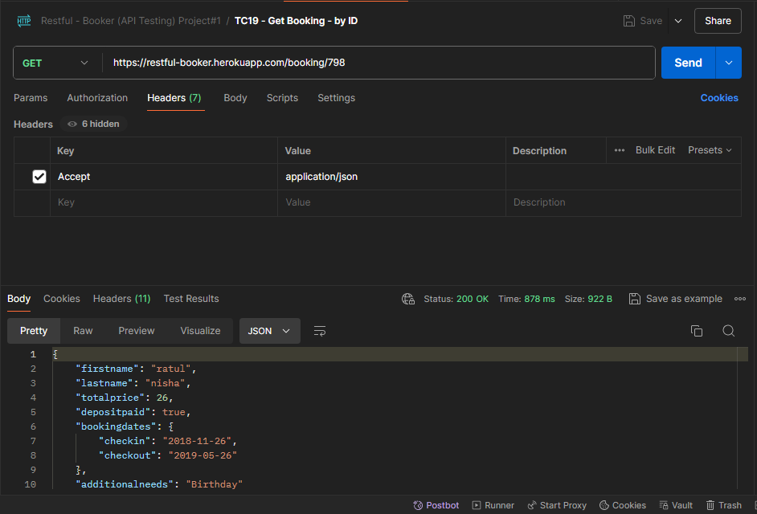

**Url** 🡪 <https://restful-booker.herokuapp.com/booking/798>

**Url Method** 🡪 GET

**Headers** 🡪

Accept:application/json

**Parameters 🡪**

**Response** 🡪 Booking ID information Retrieved Successfully (**Pass**)

{

    "firstname": "ratul",

    "lastname": "nisha",

    "totalprice": 26,

    "depositpaid": true,

    "bookingdates": {

        "checkin": "2018-11-26",

        "checkout": "2019-05-26"

    },

    "additionalneeds": "Birthday"

}

**Status** 🡪 200 OK

1. TC20 – Partial Update Booking

3 Steps needed to perform, to verify: -

1. Create a fresh booking
2. Partially Update the new booking by referring the ID
3. Get Booking by ID to verify

Creating a fresh booking

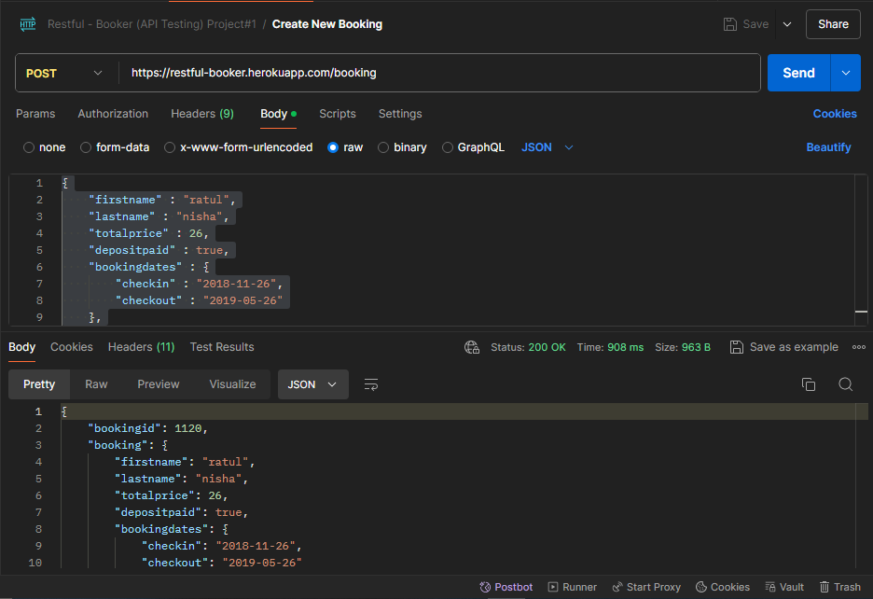

**Url** 🡪 <https://restful-booker.herokuapp.com/booking>

**Url Method** 🡪 POST

**JSON raw Data** 🡪

{

    "firstname" : "ratul",

    "lastname" : "nisha",

    "totalprice" : 26,

    "depositpaid" : true,

    "bookingdates" : {

        "checkin" : "2018-11-26",

        "checkout" : "2019-05-26"

    },

    "additionalneeds" : "Birthday"

}

**Response** 🡪 Booking ID Generated Successfully (**Pass**)

{

    "bookingid": 1120,

    "booking": {

        "firstname": "ratul",

        "lastname": "nisha",

        "totalprice": 26,

        "depositpaid": true,

        "bookingdates": {

            "checkin": "2018-11-26",

            "checkout": "2019-05-26"

        },

        "additionalneeds": "Birthday"

    }

}

**Status** 🡪 200 OK

Partially Updating the new booking by referring the ID

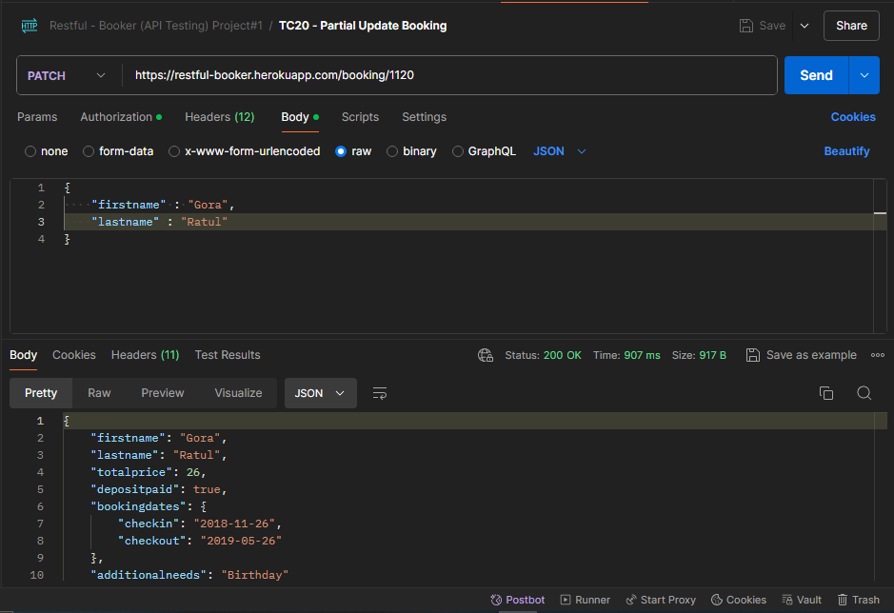

**Url** 🡪 <https://restful-booker.herokuapp.com/booking/1120>

**Url Method** 🡪 PATCH

**Headers** 🡪

Content-Type:application/json

Accept:application/json

Cookie:token=abc123

**Authorization 🡪**

Basic Authorization is needed.

**Body/Payload 🡪**

{

    "firstname" : "Gora",

    "lastname" : "Ratul"

}

**Response** 🡪 Partially Updated the details Successfully by referring the ID (**Pass**)

{

    "firstname": "Gora",

    "lastname": "Ratul",

    "totalprice": 26,

    "depositpaid": true,

    "bookingdates": {

        "checkin": "2018-11-26",

        "checkout": "2019-05-26"

    },

    "additionalneeds": "Birthday"

}

**Status** 🡪 200 OK

Get Booking by ID to verify

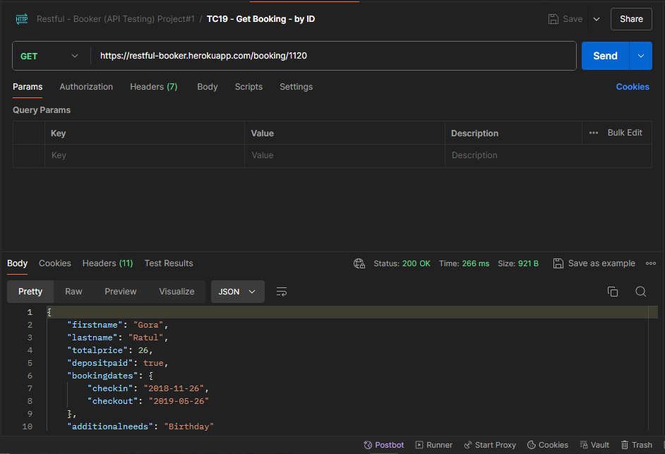

**Url** 🡪 <https://restful-booker.herokuapp.com/booking/1120>

**Url Method** 🡪 GET

**Headers** 🡪

Accept:application/json

**Response** 🡪 Booking ID details retrieved Successfully by referring the ID (**Pass**)

{

    "firstname": "Gora",

    "lastname": "Ratul",

    "totalprice": 26,

    "depositpaid": true,

    "bookingdates": {

        "checkin": "2018-11-26",

        "checkout": "2019-05-26"

    },

    "additionalneeds": "Birthday"

}

**Status** 🡪 200 OK

1. TC21 - Fully Update Current Booking

3 Steps needed to perform, to verify: -

1. Create a fresh booking
2. Fully Update the new booking by referring the ID
3. Get Booking details by ID to verify

Creating a fresh booking

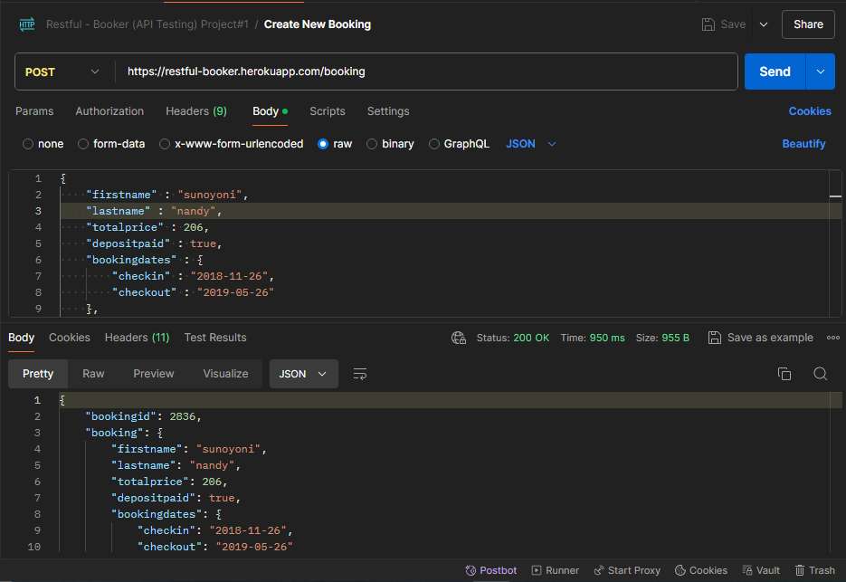

**Url** 🡪 <https://restful-booker.herokuapp.com/booking>

**Url Method** 🡪 POST

**JSON raw Data** 🡪

{

    "firstname" : "sunoyoni",

    "lastname" : "nandy",

    "totalprice" : 206,

    "depositpaid" : true,

    "bookingdates" : {

        "checkin" : "2018-11-26",

        "checkout" : "2019-05-26"

    },

    "additionalneeds" : "Birthday"

}

**Response** 🡪 Booking ID Generated Successfully (**Pass**)

{

    "bookingid": 2836,

    "booking": {

        "firstname": "sunoyoni",

        "lastname": "nandy",

        "totalprice": 206,

        "depositpaid": true,

        "bookingdates": {

            "checkin": "2018-11-26",

            "checkout": "2019-05-26"

        },

        "additionalneeds": "Birthday"

    }

}

**Status** 🡪 200 OK

Fully Updating the new booking by referring the ID

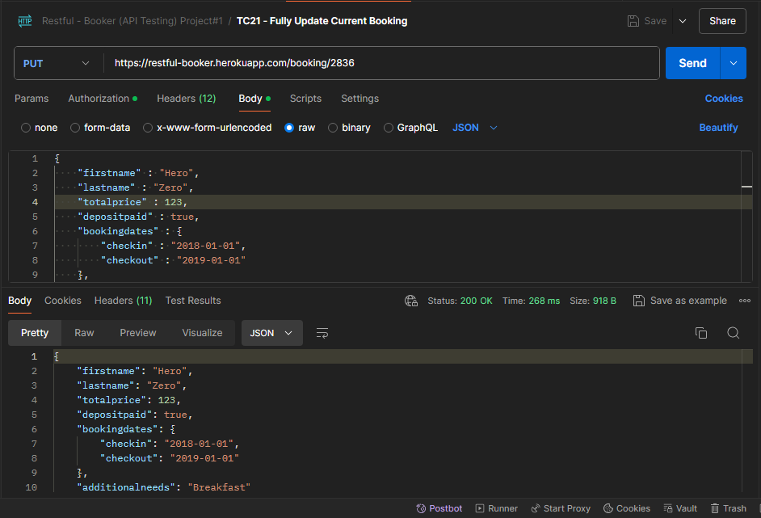

**Url** 🡪 <https://restful-booker.herokuapp.com/booking/2836>

**Url Method** 🡪 PUT

**Headers** 🡪

Content-Type:application/json

Accept:application/json

Cookie:token=abc123

**Authorization 🡪**

Basic Authorization is needed.

**Body/Payload 🡪**

{

    "firstname" : "Hero",

    "lastname" : "Zero",

    "totalprice" : 123,

    "depositpaid" : true,

    "bookingdates" : {

        "checkin" : "2018-01-01",

        "checkout" : "2019-01-01"

    },

    "additionalneeds" : "Breakfast"

}

**Response** 🡪 Partially Updated the details Successfully by referring the ID (**Pass**)

{

    "firstname": "Hero",

    "lastname": "Zero",

    "totalprice": 123,

    "depositpaid": true,

    "bookingdates": {

        "checkin": "2018-01-01",

        "checkout": "2019-01-01"

    },

    "additionalneeds": "Breakfast"

}

**Status** 🡪 200 OK

Get Booking by ID to verify

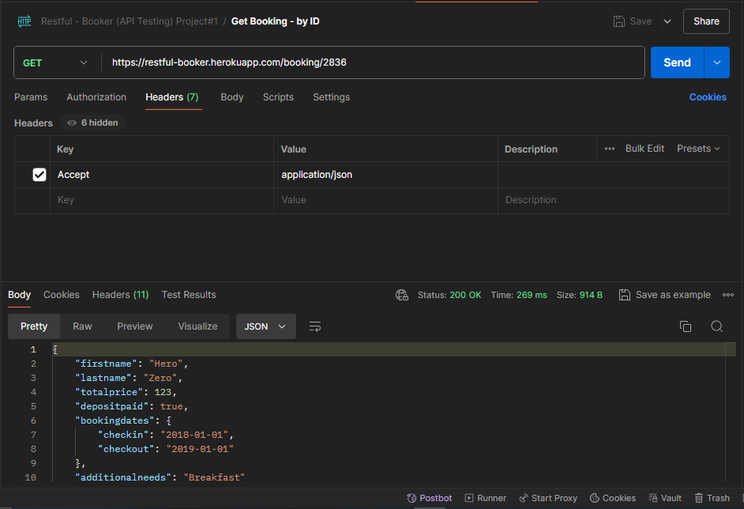

**Url** 🡪 <https://restful-booker.herokuapp.com/booking/2836>

**Url Method** 🡪 GET

**Headers** 🡪

Accept:application/json

**Response** 🡪 Booking ID details retrieved Successfully by referring the ID (**Pass**)

{

    "firstname": "Hero",

    "lastname": "Zero",

    "totalprice": 123,

    "depositpaid": true,

    "bookingdates": {

        "checkin": "2018-01-01",

        "checkout": "2019-01-01"

    },

    "additionalneeds": "Breakfast"

}

**Status** 🡪 200 OK

1. TC22 - Delete Booking

3 Steps needed to perform, to verify: -

1. Create a fresh booking
2. Delete booking by referring the ID
3. Get Deleted Booking details by ID to verify

Creating a fresh booking

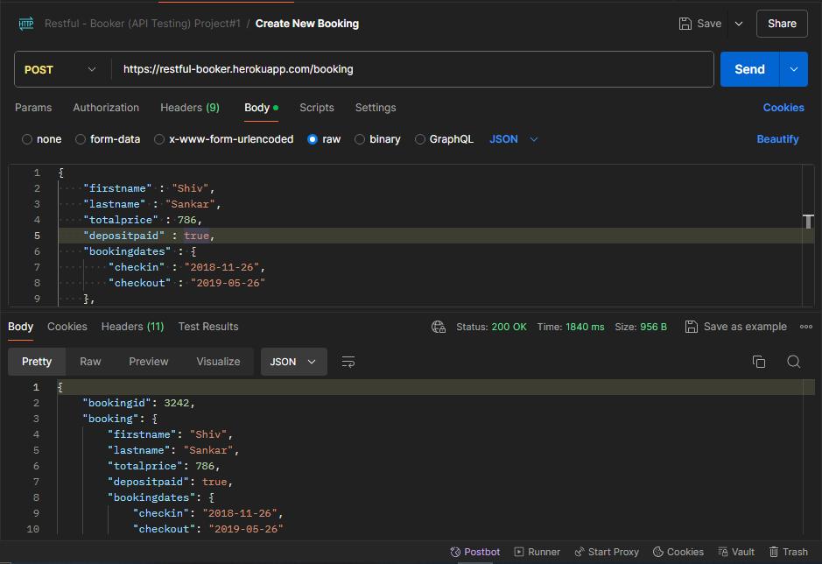

**Url** 🡪 <https://restful-booker.herokuapp.com/booking>

**Url Method** 🡪 POST

**JSON raw Data** 🡪

{

    "firstname" : "Shiv",

    "lastname" : "Sankar",

    "totalprice" : 786,

    "depositpaid" : true,

    "bookingdates" : {

        "checkin" : "2018-11-26",

        "checkout" : "2019-05-26"

    },

    "additionalneeds" : "Birthday"

}

**Response** 🡪 Booking ID Generated Successfully (**Pass**)

{

    "bookingid": 3242,

    "booking": {

        "firstname": "Shiv",

        "lastname": "Sankar",

        "totalprice": 786,

        "depositpaid": true,

        "bookingdates": {

            "checkin": "2018-11-26",

            "checkout": "2019-05-26"

        },

        "additionalneeds": "Birthday"

    }

}

**Status** 🡪 200 OK

Delete booking by referring the ID

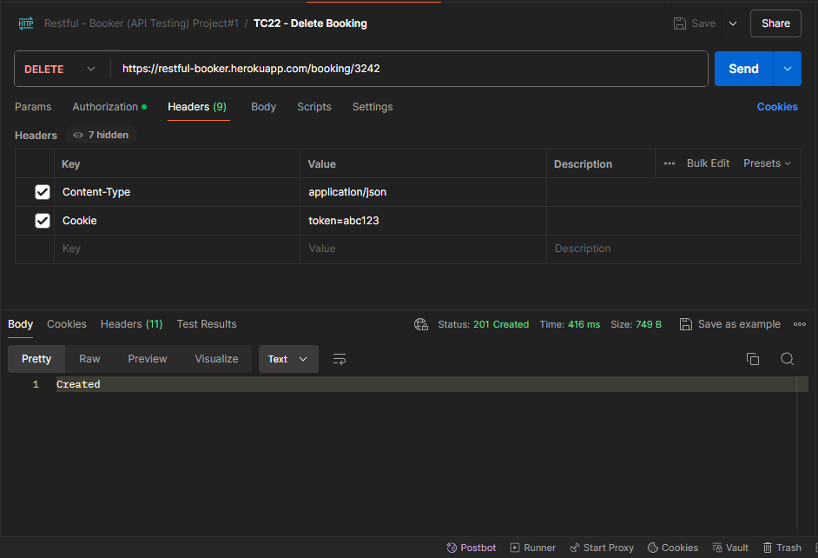

**Url** 🡪 <https://restful-booker.herokuapp.com/booking/3242>

**Url Method** 🡪 DELETE

**Headers** 🡪

Content-Type:application/json

Cookie:token=abc123

**Authorization 🡪**

Basic Authorization is needed.

**Response** 🡪 Deleted Successfully by referring the ID (**Pass**)

Created (Delete)

**Status** 🡪 201 OK

Get Booking by ID to verify

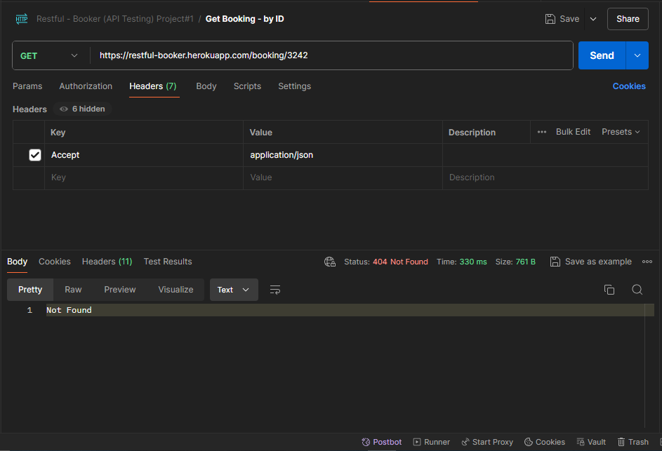

**Url** 🡪 <https://restful-booker.herokuapp.com/booking/3242>

**Url Method** 🡪 GET

**Headers** 🡪

Accept:application/json

**Response** 🡪 Deleted Booking ID details not found (**Pass**)

Not Found

**Status** 🡪 404 Not Found